Analysis of Human Neutrophil Phenotypes as Biomarker to Monitor Exercise‐Induced Immune Changes

Student’s Name
Department, University
Course Number and Name
Instructor’s Name
Date

Analysis of Human Neutrophil Phenotypes as Biomarker to Monitor Exercise‐Induced Immune Changes
Introduction
The immune system is a complex network of molecules and cells critical in protecting the host from invading microorganisms, facilitating wound healing, and disease prevention. The immune system is always very responsive to exercise that triggers specific responses to chronic and acute exercise. The degree of physiological stress is usually imposed by the exercise workload and reflected by the immune response’s amplitude. The increased risk of individuals developing infections and transient immune dysfunction has been linked to excessive physical activity (Spijkerman, Bongers, Hietbink, & Hesselink, 2020). On the other hand, regular sports and normal physical activity can help reduce infections and other diseases. As such, this has suggested that an optimal balance in exercise intensity and duration is key to having a balanced immune system. In ascertaining this fact, biomarker has been touted to be instrumental in offering a way by which the immune system can be monitored during and after repetitive bouts of a prolonged exercise. This may thus help determine the optimal exercise load and training program.
Besides protection, the immune system also influences other physiological systems and processes such as metabolism, sleep/fatigue, tissue repair, thermoregulation, and mental health. Exercise immunology has over the past four decades developed into a discipline owing to the fact that an individual’s immune system mediates many exercise effects and that stress responses mediated through the nervous and endocrine systems play a key role in determining changes in exercise-induced immune. “open window” is a classic paradigm in exercise immunology relating to immunodepression that can occur when one recovers from an intense exercise (Richard et al., 2017). According to the paradigm, some immune variables such as lymphocyte and natural killer cell numbers and antibody production transiently decrease below the pre-exercise levels after an intense exercise. As a result, microbial agents such as viruses may invade the host or reactivate from a latent state, leading to illness and infection. Severe immunodepression and potentially a longer window of opportunity for infection may occur if the exercise continues.
Acute fatigue may also happen due to repeated bouts of intense exercise on the same day or several days based on the fact that exercise-induced fatigue exists on a continuum. An athlete training intensely for 1-2 weeks is likely to experience a state of functional overreaching associated with temporary performance decrement followed by improved performance, as indicated in figure 1. A non-functional overreaching (NFOR) is also possible if intense training happens over an extended period without sufficient balance between training and recovery. Performance decrement, psychological, persistent fatigue, muscle soreness, and hormonal disturbances that last for weeks or months usually characterize this condition.

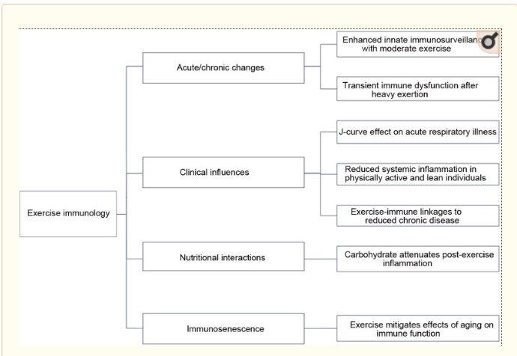
Figure 1: Key research areas and basic findings in exercise immunology
Studies have shown that an altered adaptive immunity, cytokine production, and innate immunity usually happens for several hours to days during recovery from prolonged exercise. The innate immune usually demonstrates the most pronounced changes after prolonged exercise (Nieman & M, 2019). The granulocytes and monocytes are usually the primary effectors of the innate immune system. Through flow cytometry, the receptor expression of these cells can be measured, thereby providing insight into the innate immune system's status. Intensive exercise usually leads to the mobilization of neutrophil phenotypes associated with systemic inflammation and immunosuppression. A phenotype is a neutrophil that has lost or gained a specialized function that is not shared with other phenotype cells. The phenotypes originate from the differentiation of neutrophils in the bone marrow or distant tissues, and the process is usually relatively slow (Koenderman et al., 2018). After repetitive, prolonged exercise on consecutive days, an increase in neutrophil phenotypes, CD16^{dim}/CD62L^{bright} and CD16^{bright} and CD62L^{dim}, is observed in the peripheral blood. The neutrophils CD16^{dim}/CD62L^{bright} cells are usually young with a band-shaped nucleus mostly gotten from the bone marrow. These cells mainly consist of hyper-segmented nuclei containing an immunosuppressive phenotype that is activated. This phenotype that is immunosuppressive during exercise usually exposes one to an increased risk of developing infections. Therefore, the expression of a neutrophil receptor can be a biomarker that can effectively help monitor the balance of the immune system during and after repetitive, prolonged exercise.
Recognition of neutrophil's potential role as a biomarker in monitoring exercise-induced immune response has prompted many investigations. In this mini-review, we analyzed neutrophil as a biomarker that is associated with overreaching. Neutrophil's kinetics during repetitive, prolonged walking or exercise was also analyzed.
Neutrophils as Effector Cell of the Innate Immune System
The neutrophils are regarded as old evolutionary cells that have evolved from specialized cells that gained the propensity to phagocytose target over the years. From corals to mammals, the phagocytosing cells have presences (Amulic et al., 2012). The most abundant innate immune cells in the peripheral blood are the neutrophils, and they comprise about 60% -70% of all the leucocytes (E & Kubes, 2013). The neutrophil's response to inflammatory cues coming from infectious or damaged areas outside the blood system is usually quick. These cells have several receptors that function to sense soluble inflammatory mediators ranging from cytokines to bioactive lipids. The priming response that triggers the switch to a pre-activated state is usually the first mechanism initiated by the interaction of these mediators. The priming response is typically key for the cells to interact with the vessel wall and transmigrate through the endothelium. Priming is also usually crucial as killing a mechanism that is greatly enhanced after stimulation by inflammatory mediators. For instance, neutrophils' priming with the TNF-α enhances oxygen species' production (ROS), chemotaxis, and degranulation (Koenderman et al., 2018). Also, through the release of degranulation of granule contents, the extracellular killing mechanisms are usually triggered. In the recent decade, another aspect of the extracellular mechanism has been discovered whereby the neutrophil can trap microorganisms in nets of DNA through the NETosis process.
In the peripheral blood, the number of neutrophils can change greatly relative to small changes in homeostasis. Treatment with stress hormones such as epinephrine and cortisol can help in the liberation of many additional neutrophils to the peripheral blood; a similar situation can be evoked by exercise.

Neutrophil Phenotype and function as Biomarker for Patient Survival after Trauma
It is usually important, especially in the emergency room, to have a quick and reliable prognosis. The initial inflammatory response is always thought to trigger post-traumatic organ failure. In determining the risk of infectious complications such as septic shock, the time between the life span of peripheral neutrophils and the time to produce new neutrophils from myelocytes is usually critical. The early identification and prediction of a septic shock are sometimes helpful in identifying a patient for the adaptation of the treatment regime. Studies have indicated that patients with subsequent multiple organ failure (MOF) always show significantly higher mean circulating concentrations of C3a and thromboxane B2 at the first day post-injury compared to patients without MOF (Mortaz et al., 2019). These studies also indicated that neopterin/creatinine ratios were higher in patients with MOF and established earlier. Thus, it was concluded that these mediators are critical in predicting the occurrence of secondary complications in traumatic patients, but for early realization, more studies are needed.
Inasmuch as that was the case, the study did reveal that in patients with major trauma, no significant difference in systematic C-reactive peptide and IL-6 level between survivor and non-survivor groups were witnessed. There were no found differences between the groups for terminal complement complex, neopterin/creatinine ratios, and thromboxane B2. The contrasting aspect was that plasma concentrations of neutrophil elastase, antithrombin III, IL-6, IL-8, and lactate were higher in non-survivors compared with survivors 24 h after trauma. The authors of the studies pointed out that early alterations in serum levels of IL-6 constitute a useful predictive marker in identifying a patient that is traumatic (Altichter et al., 2010). Nonetheless, the studies indicate that post-traumatic organ failure development correlates with the overall level of the initial inflammatory response.
Blood lactate in polytrauma patients and elevated serum NO and its oxidation products (NOx) are markers of a severe clinical course. Fatal prognosis in these patients may be indicated by a normal NOx combined with a very high lactate level (Beitl et al., 2016). As such, this indicates that compared to NOx, elevated levels of lactate may be a vital prognosis factor. Decreased neutrophil responsiveness appears to be a prerequisite for septic shock after trauma. The development of late-onset septic complications after >5 days relate to the initially decreased responsiveness of circulating neutrophils of N-formyl-methionyl-leucyl-phenylalanine (fMLP)-induced FcyRII. A decreased ability of fMLP to induce active FcyRII on neutrophils is usually characterized by patients having acute lung injury (ALI) or Systematic inflammatory response syndrome (SIRS). It was indicated that it seemed to be a useful marker that could show the occurrence of secondary complications.
For a study carried out on septic shock patients, for 9 of 10 of the patients, initial shock symptoms became evident between 8 and 10 days after admission. The neutrophil kinetics' measuring revealed that the lowest neutrophil responsiveness to fMLP was found within the first seven days after injury. As such, the other changes in receptor expression and the impaired responsiveness to fMLP preceded the clinical symptoms of sepsis. The CD64 expression level on day 1 was fairly perfect in predicting the outcome of critically ill patients with severe trauma and sepsis. As the best predictor of intra-abdominal infection after colorectal cancer surgery, only one study showed that CD64 expression level for neutrophils could make an early prediction. Based on the studies surrounding neutrophil phenotype and trauma, it was concluded that neutrophils play a critical role in regulating trauma. It is also an excellent predictive tool in the management of trauma patients. The delineation of its phenotype, the release of NETS-related factors, and the expression of specific cell surface markers make neutrophil a tool of significance in trauma treatment. Inasmuch as that is the case, there need to be further studies that focus on identifying the critical proteomic or transcriptomic markers pegged on defining each phenotype to allow for more rapid assessment.
Prolonged Walking and Response by Neutrophil Phenotype
A study undertaken to investigate the immune response in a general population undertaking moderate exercise was conducted. Participants with immune deficiencies or who were under immune-suppressive therapies were excluded. Thus, 39 participants participated in the study (24 males and 15 females with median age of 64 years), as shown in table 1. Collection of baseline data was done 1 or 2 days before the start of the event and each day after completing the walking exercise for 30 minutes. The absolute number of white blood cells, monocytes, eosinophils, and neutrophils are as indicated in figure 2. After one day, two additional neutrophil phenotypes increased in peripheral blood that is characteristic of systemic inflammation. Increased expression of CD11b on neutrophils was associated with slow walking speed and bad physical feeling.
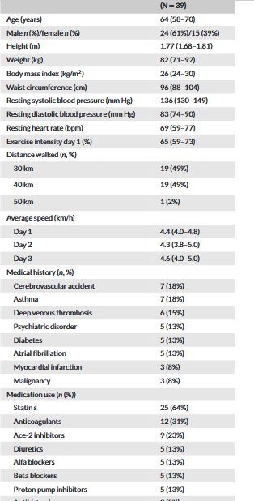
Table 1: Demographics of the study group. Continuous data are shown as median (interquartile range) and dichotomous data are shown as absolute amount (percentage)
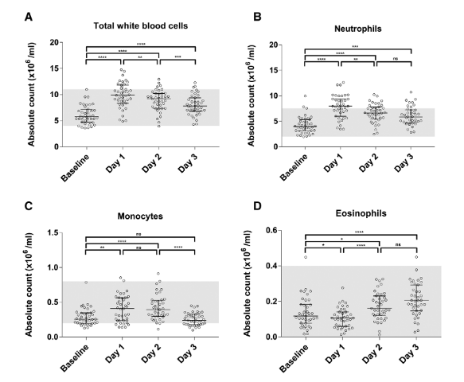
Figure 2: The absolute count of total white blood cell (A), monocytes (B), and neutrophils (C) show a significant increase on day 1, followed by decrease in the following (n=39). Eosinophils (D) show the opposite effect, as slight decrease on day 1 and after that significant increase.
This study demonstrated the mobilization and activation of different neutrophil phenotypes in peripheral blood in response to prolonged exercise. On day 1, the most pronounced immune response was found, and it was followed by partial normalization/ adaptation in the days that followed. A higher degree of physiological stress imposed by the exercise load was found among participants with elevated neutrophil CD11b expression. This indicated that CD11b expression might be a valuable marker in monitoring the changes in the immune system after a normal or a prolonged exercise. The CD35, CD11b, and CD10 neutrophil activation markers were used because they could easily demonstrate neutrophils in a fully automated flow cytometer.
A parallel study was also conducted to investigate the expression of neutrophil markers on participants of an eight-day cycling tour with a mean daily distance of 160 km. Blood sampling was done before and after 4 and 8 days of cycling. The results indicated that there was an increase in the overall neutrophil count. The biomarkers CD16^{dim}/CD62L^{bright} and CD16^{bright}/CD62L^{dim} increased after days 4 and 8 of cycling. The increase witnessed in the neutrophil biomarkers was similar for walking and cycling on day one, but they contrasted as days proceeded. For walking, the biomarkers decreased, indicating that they were adapted to the innate immune system to a certain level of exercise. The higher exercise intensity and fitness level best explain the cumulative increase of systemic immune response after 4 and 8 days. However, it could be speculated that prolonged walking of low-intensity exercise allows easy adaptation by the immune system while high-intensity cycling at higher altitude triggers the immune system’s overreaction, thus preventing adaptation. Another observation showed that participants with high neutrophil CD11b expression an increased number of CD16^{bright}/ CD62L^{dim} neutrophils. As such, this indicated that the mere presence of CD11b expression correlated with the presence of immunosuppressive CD16^{bright}/ CD62L^{dim} neutrophils prolonged exercise.
Conclusion
The neutrophils play a critical role in innate immunity and their proclivity to cause tissue injury and mandate their formation. The role they play during and after traumatic injuries cannot be underestimated. In recent times, neutrophils phenotype’s help has been extended to help monitor the immune system during and after repetitive bouts of prolonged exercise, thereby assisting in the determination of optimal exercise load and thus training program. The various studies that have been reviewed have confirmed that neutrophil phenotype can be used as a biomarker instrumental in monitoring exercise-induced immune changes.

References
Altichter, J., Faist, E., Sauer, M., Mitzner, S. R., R, K., & Zedler, S. (2010). Neutrophil-derived circulating free DNA (cf-DNA/NETs), a potential prognostic marker for mortality in patients with severe burn injury. European Journal of Trauma Emergence Surgery, 36, 551-557.
Amulic, B., Cazalet, C., Metzler, K. D., Zychlinsky, A., & GL, H. (2012). A Neutrophil function: from mechanisms to disease. Annual Revision on Immunology, 30, 459-489.
Beitl, E., Vlcek, M., Banasova, A., Hampl, V., & Mikova, D. (2016). Nitric oxide as an indicator for severity of injury in polytrauma. Bratislava Medicine Journal, 20(41), 117-217.
E, K., & Kubes, P. (2013). Neutrophil recruitment and function in health and inflamation. National Revolution on Immunology, 13, 159-175.
Koenderman, L., Vrisekoop, N., & Hellebrekers, P. (2018). Neutrophil phenotypes in health and disease. European Journal of Clinical Investigation, 48(2). Retrieved from https://www.ncbi.nlm.nih.gov/pmc/articles/PMC6282827/
Mortaz, E., Shahir, M., Garsen, J., Adcock, I. M., Mumby, S., Folkerts, G., & Zadian, S. S. (2019). Does neutrophil phenotype predict the survival of trauma patients? Frontiers in Immunology.
Nieman, D. C., & M, W. L. (2019). The compelling link between physical activity and the body's defense system. Journal of Sport and Health Science, 8(3), 201-217.
Richard, S. J., Neubauer, O., & Peake, J. M. (2017). Recovery of the Immune system after exercise. Journal of Applied Physiology.
Spijkerman, R., Bongers, C. C., Hietbink, F., & Hesselink, L. (2020). Analysis of human neutrophil phenotypes as biomaker to monitor exercise-induced immune changes. Journal of Leukocyte, 1-10.

